Pabna University of Science and Technology



DEPARTMENT OF STATISTICS
Statistical Project on
“Machine Learning Approaches for Early Detection of Lung Cancer: A Comparative Analysis”
(According to B.Sc. Honors Syllabus 2017-18)
A Project report submitted in partial fulfilment of the requirements for the degree of B.Sc. in Statistics
SUPERVISED BY
Md. Shahajada Mia
Assistant Professor
Dept. of Statistics, PUST

SUBMITTED BY
Roll No: 181632
Registration No: 1165106
Session: 2017-18
Dep. of Statistics, PUST
Pabna University of Science and Technology

CANDIDATE’S DECLARATION

This is to certify that the work presented in this thesis, titled, “Machine Learning Approaches for Early Detection of Lung Cancer: A Comparative Analysis” the results of the research conducted by me under the supervision of Md. Shahajada Mia
It is also announced that this project or any part of it has not been submitted anywhere else for the award of any degree, diploma or other qualification.

---------------------------------------------
181632

CERTIFICATION

This project titled “Comparative Analysis of Machine Learning Approaches for Early Detection of Lung Cancer” submitted by Nazmul Hossen, the requirements for the degree B.Sc. in Statistics as mentioned below have been accepted as satisfactory in partial fulfillment.

Submitted By:
Roll-181602

Supervisor
Md. Shahajada Mia
Assistant Professor
Dept. of Statistics,PUST

ACKNOWLEDGEMENT
At first, I would like to express gratitude to the Almighty for blessing me to bring out a successful project work. I would like to express profound respect to my respected supervisor Md. Shahajada Mia for his continuous motivation, supportive management and proper guidance without the thesis work would not have been completed successfully. I am deeply thankful to him to introduce me to work in the field of deep neural network and give valuable suggestions in case of any problem while working on this thesis topic. He also helped me reviewing my draft thesis work and giving proper solutions to make my thesis work fruitful.

A special thank you goes to Dr. Md. Shamim Reza, Dr. Sabba Ruhi, , Most. Mira Khatun, and the entire faculty of the Department of Statistics for their steadfast academic and logistical support.

And finally, I am grateful to my family, friends and others who supported me continuously and gave inspiration throughout the entire thesis work to complete it within a certain period.

Pabna
17 September 2024.

Table of Contents
Contents | Page
Title | i
CANDIDATE’S DECLARATION | ii
Certificate of Approval | iii
Acknowledgement | iv
Abstract | viii
Chapter One
PRELIMINARIES
Introduction | 1
Background | 2
Problem Statement | 3
Objectives of the Study | 4
Scope of the Study | 5
Chapter Two (Literature Review)
Literature Review | 6-10
Chapter Three
Dataset Description and Data Preprocessing
Dataset Description | 11
Data Preprocessing and Feature Engineering | 12-15
Graphical Representation of the Dataset | 16-17
Correlation between Features | 18-19
Chapter Four
Machine Learning Algorithm Description
Introduction | 20
Logistic Regression | 20-22
Support Vector Machine | 22-23
Random Forest Algorithm | 24-25
Neural Networks | 25-26
XG Boost | 26
Model Evaluation (Confusion Matrix) | 27-31
Chapter Five
Data Analysis and Results Discussion
Logistic Regression Results | 32-34
Support Vector Machine Results | 35-37
Random Forest Algorithm Results | 38-40
Neural Networks MLP Classifier Results | 41-44
Extreme Gradient Boosting Results | 45-48
Model Comparison and Comparative Analysis | 48-50
Chapter Six
Conclusion and Recommendations
Conclusion | 51
Recommendations | 52
References | 53

List of Table
Table No. | Name | Page No.
Table 3.1 | Variable Description of the dataset | 8
Table 3.2 | Missing Data in the variable | 9
Table 3.3 | Outliers in the dataset | 10
Table 3.4 | After normalizing, head of the dataset | 11-12
Table 3.5 | Using PCA result of explained variance ratio | 13
Table 5.1 | Overall Accuracy of Logistic Regression results | 14
Table 5.2 | Classification Report of Logistic Regression (Training Set) | 15
Table 5.3 | Classification Report of Logistic Regression (Testing Set) | 16-17
Table 5.4 | Classification Report of Support Vector Machine | 18-19
Table 5.5 | Classification Report of Support Vector Machine (Training Set) | 20
Table 5.6 | Classification Report of Support Vector Machine (Testing Set) | 21-22
Table 5.7 | Classification Report of Random Forest Algorithm | 23
Table 5.8 | Classification Report of Random Forest Algorithm (Training Set) | 24
Table 5.9 | Classification Report of Random Forest Algorithm (Testing Set) | 25
Table 5.10 | Classification Report of Neural Networks MLP Classifier | 26
Table 5.11 | Classification Report of Neural Networks MLP Classifier (Training Set) | 27
Table 5.12 | Classification Report of Neural Networks MLP Classifier (Testing Set) | 28
Table 5.13 | Classification Report of Extreme Gradient Boosting | 29
Table 5.14 | Classification Report of Extreme Gradient Boosting (Training Set) | 30
Table 5.15 | Classification Report of Extreme Gradient Boosting (Testing Set) | 31-32
Table 6.1 | Comparison of Different Model | 33

List of Figure
Figure No. | Name | Page No.
Figure 3.1 | Age of respondents | 7
Figure 3.2 | Age of patients when diagnosed with cancer | 8
Figure 3.3 | Percent of smokers having lung cancer
Figure 3.4 | Percent of alcohol consumption having lung cancer
Figure 3.5 | Correlation Matrix Visualization of the variables in the dataset | 9
Figure 4.1 | Logistic Regression | 10
Figure 4.2 | SVMs Optimize Margin Between Support Vectors or Classes | 11
Figure 4.3 | Random Forest Algorithm | 12
Figure 4.4 | Neural Networks | 13
Figure 4.5 | XG Boost | 14
Figure 4.6 | Confusion Matrix | 15-16
Figure 4.7 | Area Under the ROC Curve (AUC) | 17
Figure 5.1 | Training confusion matrix of Logistic Regression
Figure 5.2 | Testing confusion matrix of Logistic Regression
Figure 5.3 | Training confusion matrix of Support Vector Machine | 20
Figure 5.4 | Testing confusion matrix of Support Vector Machine | 21
Figure 5.5 | Training confusion matrix of Random Forest Algorithm | 22
Figure 5.6 | Testing confusion matrix of Random Forest Algorithm | 23
Figure 5.7 | Training confusion matrix of Neural Networks MLP Classifier | 24
Figure 5.8 | Testing confusion matrix of Neural Networks MLP Classifier | 25
Figure 5.9 | Training confusion matrix of Extreme Gradient Boosting | 26
Figure 5.10 | Testing confusion matrix of Extreme Gradient Boosting | 27
ABSTRACT
Lung cancer is one of the leading causes of cancer-related deaths worldwide, primarily due to the difficulty in detecting the disease at an early stage. Early detection of lung cancer significantly improves treatment outcomes and survival rates. This study explores the application of machine learning (ML) techniques for the early detection of lung cancer, evaluating the performance of various models, including Logistic Regression, Support Vector Machine (SVM), Random Forest, Neural Networks (MLP), and Extreme Gradient Boosting (XG Boost). The goal is to assess how these models perform in terms of accuracy, precision, recall, and F1-score using a publicly available dataset.

The results reveal that while Logistic Regression and SVM offer more stable generalization, with testing accuracies of 51.67% and 50.67%, respectively, models like Random Forest and XGBoost show signs of overfitting, with significant performance drops from training to testing phases. Despite achieving high training accuracy, these models struggle to generalize to new data, highlighting the need for careful tuning and feature selection. The Neural Network model shows promise but requires further optimization to improve generalization.

A comparative analysis of the models is conducted, along with an evaluation of the challenges associated with their implementation in real-world clinical settings, such as overfitting, data quality, and model interpretability. The ROC curve analysis demonstrates that Logistic Regression has the highest Area Under the Curve (AUC) at 0.52, indicating slightly better performance compared to the other models. However, none of the models significantly outperform random guessing, emphasizing the need for future research to refine these approaches.

This research provides valuable insights into the limitations and potential of ML models for early lung cancer detection, and suggests improvements to enhance their clinical applicability. By addressing these challenges, machine learning could become a powerful tool for assisting healthcare professionals in diagnosing lung cancer at an earlier, more treatable stage.
Keywords: Logistic Regression, Support Vector Machine, Random Forest, Neural Network, XG Boost, Overfitting.
Chapter one
PRELIMINARIES
1.1 Introduction
Lung cancer (LC) remains one of the most prevalent and deadly cancers globally, with a high mortality rate due to its often asymptomatic early stages. This silent progression significantly hampers early detection, which is critical for improving patient outcomes and survival rates. Traditional methods for diagnosing lung cancer, primarily through imaging techniques like computed tomography (CT) scans, have laid the groundwork for leveraging advanced technologies to enhance diagnostic accuracy [1].
Recent advancements have integrated machine learning (ML) and deep learning (DL) algorithms into the diagnostic process, providing promising tools for early detection. These automated systems offer the potential to significantly improve accuracy in distinguishing between various types of lung cancer and enhancing overall patient care. However, the effectiveness of these ML models varies, with some achieving high accuracy rates, such as 98.7%, while others face challenges in maintaining high performance across different datasets [2].
Despite these advancements, the application of ML in lung cancer detection is not without difficulties. For instance, deep learning algorithms have shown high sensitivity but variable specificity, highlighting the need for ongoing refinement. The accuracy of models like Logistic Regression, Support Vector Machines (SVM), Random Forests, Neural Networks, and Extreme Gradient Boosting (XG Boost) varies significantly, with some models showing signs of overfitting and others demonstrating modest performance.
This paper aims to provide a comparative analysis of various ML and DL techniques applied to lung cancer detection. By evaluating models based on their accuracy, precision, recall, and F1-score, as well as their ability to generalize from training to testing data, we assess their effectiveness and limitations. The study also explores the ROC curve to determine the discriminative power of these models. The findings highlight the need for further refinement and optimization to improve diagnostic accuracy and clinical applicability.

1.2 Background

Lung cancer remains one of the leading causes of cancer-related deaths worldwide, accounting for millions of lives each year. It is primarily classified into two major types: non-small cell lung cancer (NSCLC) and small cell lung cancer (SCLC). These classifications are based on the biological characteristics of the tumor cells and have varying treatment approaches and prognoses. A major factor contributing to the high mortality rate of lung cancer is the delayed diagnosis, as the disease is often asymptomatic in its early stages. By the time symptoms appear, the cancer has often progressed to an advanced stage, making effective treatment difficult and survival rates significantly lower.
In recent years, advancements in medical imaging technologies such as computed tomography (CT) scans have enabled more accurate screening and diagnosis of lung cancer. However, interpreting these large and complex imaging datasets requires significant time and expertise, which introduces a need for automated systems. Machine learning (ML) and deep learning (DL) techniques have emerged as powerful tools in this regard, offering the ability to analyze vast amounts of medical data efficiently and identify patterns that may be indicative of early-stage cancer.
Research in the application of ML in healthcare has accelerated, with a focus on improving the early detection of diseases like lung cancer. By utilizing predictive models based on algorithms such as logistic regression, support vector machines (SVM), random forests, and neural networks, researchers aim to enhance diagnostic accuracy, identify high-risk patients earlier, and improve survival rates. While these technologies offer great promise, challenges such as model generalization, overfitting, and the need for large, diverse datasets remain.
This study aims to explore the performance of various machine learning approaches for early detection of lung cancer, comparing their effectiveness and identifying key challenges associated with implementing these techniques in clinical practice. Understanding these challenges is critical for the future integration of ML-based diagnostic tools into routine healthcare, potentially transforming how lung cancer is detected and treated.

1.3 Problem Statement
Lung cancer is one of the most prevalent and deadly forms of cancer globally, with a high mortality rate due to its often late diagnosis. Early detection is critical for improving patient outcomes, yet traditional diagnostic methods, such as imaging and biopsies, are time-consuming, expensive, and require significant expertise to interpret accurately. Despite advancements in imaging technologies like computed tomography (CT) scans, many lung cancer cases remain undetected in their early stages, leading to reduced treatment effectiveness and poor survival rates.
In recent years, machine learning (ML) and deep learning (DL) techniques have shown potential in automating the early detection of lung cancer by analyzing complex medical data. However, the application of these techniques in clinical settings faces several challenges. Issues such as overfitting, insufficient generalization to diverse patient populations, and the need for large, annotated datasets hinder their effectiveness. Additionally, while some ML models show high accuracy in research settings, their performance in real-world clinical environments is often inconsistent, raising concerns about their reliability and practical applicability.
The problem this study addresses is the need for a comprehensive evaluation of machine learning approaches for the early detection of lung cancer. Specifically, it seeks to compare the performance of different models, identify their limitations, and explore potential improvements to make these technologies more viable for clinical use. This study will also address the challenges of data quality, model validation, and generalizability, which are critical for ensuring the successful integration of ML-based diagnostic tools in routine healthcare practices.

1.4 Objectives of the Study
The primary objective of this study is to evaluate the performance of various machine learning (ML) approaches for the early detection of lung cancer and to identify the key challenges associated with their implementation in clinical practice. Specifically, the study aims to:

- Compare the performance of different ML models (e.g., Logistic Regression, Support Vector Machine, Random Forest, Neural Networks, XG Boost) in terms of accuracy, precision, recall, and F1-score, for predicting lung cancer using publicly available datasets.
- Assess the generalizability of these models by examining their ability to maintain predictive accuracy across training and testing datasets and determining the extent of overfitting or under fitting.
- Identify the limitations and challenges associated with using ML techniques for lung cancer detection, including issues related to model complexity, data quality, and interpretability.
- Explore potential improvements to enhance model performance, such as optimizing feature selection, data preprocessing techniques, and tuning hyper parameters to improve prediction accuracy and reduce overfitting.
- Provide insights into the practical applicability of ML-based diagnostic tools for lung cancer, suggesting ways to make these technologies more reliable and feasible for real-world clinical use.

Scope of the Study
The scope of this study encompasses the following key areas:
- Machine Learning Techniques: This research focuses on the application and evaluation of various machine learning algorithms, including Logistic Regression, Support Vector Machine (SVM), Random Forest, Neural Networks (MLP), and Extreme Gradient Boosting (XG Boost), for the early detection of lung cancer.
- Data Analysis: The study utilizes publicly available datasets related to lung cancer to train and test machine learning models. The analysis will assess the models' performance in terms of accuracy, precision, recall, and F1-score.
- Model Comparison: The study conducts a comparative analysis of the performance of the machine learning models, identifying their strengths and limitations. Particular emphasis will be placed on evaluating the generalizability of these models to ensure they do not suffer from overfitting or under fitting.
- Challenges and Limitations: The study explores the challenges associated with implementing machine learning techniques for lung cancer detection, such as data quality, model interpretability, computational complexity, and real-world applicability in clinical settings.
- Recommendations for Improvement: Based on the analysis and findings, the study aims to provide recommendations for improving model performance, optimizing feature selection, and addressing challenges to make machine learning models more practical for lung cancer diagnosis.
- Clinical Relevance: While the study primarily focuses on the technical aspects of machine learning for lung cancer detection, it also highlights the potential impact of these techniques in a clinical setting, offering insights into how machine learning tools can support healthcare professionals in diagnosing lung cancer earlier and more accurately.
The study is limited to the available dataset characteristics, such as the features and patient demographics provided, and the machine learning methods applied within the scope of this research. It does not include the development of new machine learning models but evaluates the effectiveness of existing approaches.
Chapter Two
2. Literature Review
The scientific community has increasingly focused on leveraging advanced technologies to enhance early detection and treatment of critical diseases, lung cancer.Lung cancer stands as the leading cause of cancer-related deaths worldwide, making timely diagnosis crucial for improving survival rates. Recent advancements in machine learning (ML) have opened new avenues for developing predictive models and diagnostic tools capable of analyzing vast and complex medical datasets. This section reviews the latest studies employing machine learning algorithms to improve the accuracy and efficiency of lung cancer detection and diagnosis, highlighting the growing role of these techniques in transforming healthcare outcomes.
Lung cancer remains the leading cause of cancer-related mortality globally, making early detection, prediction, and diagnosis essential for improving patient outcomes. The integration of machine learning (ML) techniques in healthcare has demonstrated promise in enhancing the accuracy of lung cancer diagnosis and treatment. ML algorithms, such as Naive Bayes, Support Vector Machines (SVM), Logistic Regression, and Artificial Neural Networks (ANN), are increasingly being employed in the prognosis and analysis of lung cancer due to their ability to analyze large datasets and identify patterns that might be missed by traditional methods [2].
Cai et al. [3] conducted a study using a combination of ROC (Receiver Operating Characteristic) analysis, Random Forests (RFs), and Maximum Relevancy and Minimum Redundancy (mRMR) methods to identify molecular signatures. These signatures were used in ML models to classify lung adenocarcinoma (LADC), squamous cell carcinoma (SQCLC), and small cell lung cancer (SCLC). The study identified a panel of 16 DNA methylation markers that exhibited high classification accuracy, achieving 86.54% accuracy and 84.6% recall in leave-one-out cross-validation (LOOCV), and 85.5% recall in independent data set tests.
Lalitha [4] developed an automated lung cancer detection system using ML algorithms. The study highlighted the use of advanced imaging techniques, such as CT scans, combined with ML to significantly enhance diagnostic accuracy. The system achieved a high accuracy rate, with nearly 98.7% detection accuracy, demonstrating the potential of ML in distinguishing between different types of lung cancer and supporting healthcare professionals in their diagnoses.
Forte et al. [5] conducted a systematic review and meta-analysis on the use of deep learning algorithms in lung cancer diagnosis. Their analysis revealed strong diagnostic performance, with a pooled sensitivity of 93% and a specificity of 68%. Despite considerable heterogeneity, primarily due to the threshold effect, the summary receiver operating characteristic (SROC) curve yielded an AUC of 0.90, indicating a high level of accuracy. These findings underscore the potential of deep learning as a reliable tool in lung cancer diagnosis, though further refinement is required to improve specificity.
Bharathy and Pavithra [6] explored the use of multi-stage classification methods in lung cancer detection, with particular emphasis on image segmentation techniques. The study employed methods such as Thresholding, Marker-Controlled Watershed, and Binary Classification for image segmentation, followed by classification using various ML algorithms. Among these, Random Forest demonstrated the highest accuracy, achieving 88.5%. This approach highlighted the importance of image segmentation in improving classification accuracy and patient outcomes.
Patra and Radhanath [7] explored the use of machine learning classifiers to predict lung cancer by analyzing data from the UCI repository. The study emphasized the importance of early detection due to the high mortality rate associated with lung cancer, despite advancements in medical diagnostics. Various machine learning techniques were applied after preprocessing the data into binary form using the Weka tool. The study concluded that the RBF classifier achieved an accuracy of 81.25%, making it an effective method for classifying lung cancer cases as benign or malignant.
Taher et al. [8] provided a comprehensive overview of various lung cancer classification algorithms and their performance. Their study evaluated machine learning approaches, including Convolutional Neural Networks (CNN), Support Vector Machines (SVM), Artificial Neural Networks (ANN), Multi-Layer Perceptron (MLP), K-Nearest Neighbors (KNN), Entropy Degradation Method (EDM), and Random Forest (RF). The study assessed each algorithm based on accuracy, sensitivity, and specificity. CNN, when applied to a small dataset, achieved the best result with 96% accuracy, whereas EDM performed the worst with an accuracy of 77.8%. This analysis highlighted CNN’s superior performance in lung cancer detection, while EDM showed relatively poor results in comparison.
Modak et al. [9] explored the use of machine learning algorithms for early detection of lung cancer, focusing on reducing treatment costs and improving diagnosis accuracy. The study developed various ML models, including XGBoost, Decision Tree, Random Forest, Logistic Regression, and Naïve Bayes. XGBoost performed the best, achieving an accuracy of 95.92%, followed by Random Forest with 93.32%, Decision Tree with 91.50%, Naïve Bayes with 90.32%, and Logistic Regression with 57.41%. The study highlights the potential of these models in aiding physicians to make more efficient treatment decisions.
Hoque et al. [10] proposed an automated method for detecting lung cancer using CT scan images. Their approach integrates image processing techniques and machine learning to identify lung cancer at its early stages. The study utilizes steps such as image enhancement, filtering, segmentation, feature extraction, and classification through Support Vector Machine (SVM). The objective is to achieve high diagnostic accuracy, and the experimental results demonstrate the effectiveness of the proposed framework.
Khan, Razib Hayat, et al.[11] explored Lung cancer, a leading cause of death in the USA, often stems from malignant tumors and smoking-related issues. Early detection can prevent severe outcomes and reduce treatment costs. Machine learning models are useful for predicting early-stage cancer and improving diagnostic efficiency. XGBoost achieved the highest accuracy at 95.92%, with LightGBM (91.50%), AdaBoost (93.32%), Logistic Regression (57.41%), and Support Vector Machine (89.32%) following. These models enhance diagnosis and potentially lower treatment expenses.
Singh et al. [12] investigated various machine learning algorithms for predicting and detecting lung cancer, a critical disease with high mortality rates. Their study highlights the importance of early detection in improving patient survival rates. By utilizing medical imagery such as X-rays and CT scans, several ML models have been developed, with some achieving accuracies up to 98%. This research provides a comprehensive overview of different ML models that enhance cancer detection and aid radiologists in making better diagnostic decisions.
Paliwal and Kurmi [13] review various machine learning approaches for detecting lung cancer, a critical disease exacerbated by concurrent COVID-19 issues. The paper emphasizes the use of medical image processing (MIP) techniques combined with machine learning to enhance cancer detection. By utilizing deep neural networks and analyzing training datasets, these methods improve the accuracy of cancer detection and prediction. The review discusses different techniques and their specifications, highlighting the effectiveness of these approaches in diagnosing lung cancer through advanced imaging and machine learning.
Karhan and Tunç [14] examined lung cancer detection using blood values from Ondokuz Mayıs University. The study compared various classification algorithms—k-nearest neighbors, support vector machines, naive bayes, artificial neural networks, and logistic regression—based on their performance metrics, including accuracy, F1 measure, precision, sensitivity, and specificity. The results indicated that support vector machines and neural networks performed the best in detecting lung cancer, followed by k-nearest neighbors, logistic regression, and naive bayes. This study highlights the effectiveness of machine learning algorithms in utilizing hematological data for cancer diagnosis.
Chaturvedi et al. [15] explore the critical issue of lung cancer, one of the most fatal and prevalent cancers, with about 70,000 new cases annually in India. Early detection is crucial for improving survival rates. The paper reviews various computer-aided diagnosis (CAD) systems that utilize machine learning, deep learning, and image processing techniques to detect and classify lung cancer at early stages. By discussing and comparing different methods for image segmentation, feature extraction, and classification, the study aims to highlight the effectiveness of these technologies in enhancing early cancer detection.
Juma et al. [16] address the challenge of early lung cancer detection, crucial for improving patient survival rates. The study utilizes image processing techniques for pre-processing, segmentation, and feature extraction, with artificial neural networks (ANNs) employed for detecting nodules based on features such as shape, size, and volume. Principal component analysis (PCA) is used to manage complex relationships among patient data and treatment variables. The approach, implemented using MATLAB and XLSTART, classifies lung images into normal or nodule types (benign or malignant) and achieved an accuracy of 76% in detecting lung cancer.

Bharati et al. [17] explore various classification algorithms for diagnosing lung cancer, a leading cause of cancer deaths globally, primarily due to cigarette smoking. Using a dataset from the UCI machine learning repository, the study evaluates the performance of Naïve Bayes, Logistic Regression, K-Nearest Neighbors (KNN), Decision Trees, Random Forest, and Neural Networks in predicting lung cancer. The paper compares these algorithms based on accuracy, precision, recall, F1 score, and visualizations such as ROC curves and confusion matrices. Additionally, Principal Component Analysis (PCA), Multidimensional Scaling (MDS), and Hierarchical Clustering were employed to enhance and analyze the classification results.
Shaikh and Rao [18] review the application of machine learning (ML) and deep learning (DL) methods in cancer research, focusing on their role in early screening and treatment. The study highlights various ML techniques, including artificial neural networks (ANNs), support vector machines (SVMs), and decision trees (DTs), for classifying patients into high- or low-risk categories. These methods are essential for developing predictive models and understanding cancer progression. The paper emphasizes the need for high validity in these ML models to ensure their effective integration into clinical practice.
Makaju et al. [19] provided a detailed analysis of computer-aided techniques used to detect lung cancer in CT scan images. Their research identified multiple methods for diagnosing lung cancer and ranked them based on detection accuracy. Some methods showed higher accuracy rates, but none reached close to 100%. This study highlighted the need for continuous improvements in current methods to achieve higher diagnostic accuracy. The goal is to move toward a computer-aided system that approaches 100% accuracy by addressing the limitations and drawbacks of existing techniques.

CHAPTER THREE
Dataset Description and Data Preprocessing
3.1 Dataset Description
The dataset used in this study was sourced from Kaggle [24] and focused on healthcare data related to lung cancer. It consisted of 3000 observations with sixteen features and one target output. The dataset included information from participants, with each attribute described as follows:

Table 3.1: Variable Description of the dataset.
No. | Variable | Description | Categories
1 | GENDER | Describes the participant's gender | 'M' (male), 'F' (female)
2 | AGE | Quantifies participants' age in years | Continuous
3 | SMOKING | Indicates whether the respondent is a smoker | 1 (smoker), 2 (non-smoker)
4 | Yellow Fingers | Indicates whether the participant has yellow fingers | 1 (yes), 2 (no)
5 | Anxiety | Indicates whether the respondent has anxiety | 1 (yes), 2 (no)
6 | Peer Pressure | Records if peer pressure is influencing the participant | 1 (yes), 2 (no)
7 | Chronic Disease | Indicates whether the participant has a chronic disease (e.g., COPD) | 1 (yes), 2 (no)
8 | Fatigue | Measures the participant’s experience with fatigue | 1 (yes), 2 (no)
9 | Allergy | Indicates if the participant has allergies | 1 (yes), 2 (no)
10 | Wheezing | Describes whether the participant experiences wheezing | 1 (yes), 2 (no)
11 | Alcohol Consuming | Indicates whether the respondent consumes alcohol | 1 (yes), 2 (no)
12 | Coughing | Records whether the participant has a cough | 1 (yes), 2 (no)
13 | Shortness of Breath | Describes whether the participant experiences shortness of breath | 1 (yes), 2 (no)
14 | Swallowing Difficulty | Describes whether the participant has difficulty swallowing | 1 (yes), 2 (no)
15 | Chest Pain | Indicates whether the participant has chest pain | 1 (yes), 2 (no)
16 | Lung Cancer | Target variable indicating whether the participant has lung cancer | 'YES', 'NO'

3.2 Data Preprocessing and Feature Engineering

Data preprocessing was crucial in this study to address missing values, detect outlier, and prepare the dataset for analysis. Several steps were performed, including redundant value reduction, feature selection, and data discretization. The following details the data preprocessing steps conducted:
3.2.1 Handle Missing Data: Ensure the dataset is clean by addressing missing or inconsistent values.

Table 3.2: Missing Data in the variable.
Variable | Number of Missing Value
GENDER | 0
AGE | 0
SMOKING | 0
YELLOW_FINGERS | 0
ANXIETY | 0
PEER_PRESSURE | 0
CHRONIC_DISEASE | 0
FATIGUE | 0
ALLERGY | 0
WHEEZING | 0
ALCOHOL_CONSUMING | 0
COUGHING | 0
SHORTNESS_OF_BREATH | 0
SWALLOWING_DIFFICULTY | 0
CHEST_PAIN | 0
LUNG_CANCER | 0

3.2.2 Outlier Detection and Replacement:
The IQR (Interquartile Range) method was used to detect outliers in the dataset. In the preprocessing stage, the Interquartile Range (IQR) method was employed to identify and handle outliers in the dataset. The IQR is a measure of statistical dispersion and is calculated as the difference between the third quartile (Q3) and the first quartile (Q1). This method is effective for detecting outliers, which are defined as values that fall below Q1−1.5×IQR or above Q3+1.5×IQR
For each numerical feature in the dataset:
- Calculate Q1 and Q3: Determine the first quartile (25th percentile) and the third quartile (75th percentile) for each feature.
- Compute IQR: Subtract Q1 from Q3 to obtain the IQR.
- Identify Outliers: Define the lower bound as Q1−1.5×IQR and the upper bound as Q3+1.5×IQR. Any data point outside these bounds is considered an outlier.
- Replace Outliers: Outliers can be handled by various methods, such as replacing them with the median value of the feature or capping them to the nearest non-outlier value.

- Table 3.3: Outliers in the dataset
Outliers | Variable
Detected 0 outliers in column | GENDER
Detected 0 outliers in column | AGE
Detected 0 outliers in column | SMOKING
Detected 0 outliers in column | YELLOW_FINGERS
Detected 0 outliers in column | ANXIETY
Detected 0 outliers in column | PEER_PRESSURE
Detected 0 outliers in column | CHRONIC_DISEASE
Detected 0 outliers in column | FATIGUE
Detected 0 outliers in column | ALLERGY
Detected 0 outliers in column | WHEEZING
Detected 0 outliers in column | ALCOHOL_CONSUMING
Detected 0 outliers in column | COUGHING
Detected 0 outliers in column | SHORTNESS_OF_BREATH
Detected 0 outliers in column | SWALLOWING_DIFFICULTY
Detected 0 outliers in column | CHEST_PAIN

3.2.3 Encoding
Categorical features in the dataset were transformed into numerical format through encoding. One-Hot Encoding was applied to create binary columns for each category, ensuring that categorical data is represented in a format suitable for machine learning algorithms. Label Encoding was also used for specific categorical features to assign unique integers to each category. These encoding methods facilitated the effective processing of categorical data.

3.2.4 Feature Scaling: Standardize or normalize the features if needed, especially for models like SVM.After normalizing the dataset, head of the dataset.
Table 3.4: After normalizing, head of the dataset.

AGE | SMOKING | YELLOW_FINGERS | ANXIETY | PEER_PRESSURE
0.667808 | -0.982159 | -1.028403 | -0.988071 | 1.002002
-0.011480 | -0.982159 | 0.972381 | 1.012073 | -0.998002
1.550883 | 1.018165 | 0.972381 | -0.988071 | -0.998002
0.328164 | 1.018165 | -1.028403 | -0.988071 | -0.998002
CHRONIC_DISEASE | FATIGUE | ALLERGY | WHEEZING | ALCOHOL_CONSUMING
0.980850 | -0.979543 | 0.986754 | 1.005348 | 1.017486
-1.019524 | 1.020885 | 0.986754 | 1.005348 | -0.982814
-1.019524 | 1.020885 | -1.013423 | 1.005348 | -0.982814
0.980850 | -0.979543 | 0.986754 | -0.994681 | -0.982814

COUGHING | SHORTNESS_OF_BREATH | SWALLOWING_DIFFICULTY | CHEST_PAIN | GENDER_M
0.978889 | 1.024295 | 1.020885 | -0.997337 | 0.990710
-1.021566 | -0.976281 | 1.020885 | 1.002670 | -1.009377
-1.021566 | 1.024295 | -0.979543 | -0.997337 | -1.009377
0.978889 | -0.976281 | 1.020885 | 1.002670 | 0.990710

3.2.5 Feature Selection: Dimensionality reduction techniques are employed to reduce the complexity of data while preserving important features. Use methods like Principal Component Analysis (PCA) to reduce dimensionality and improve model performance .We use PCA for Feature selection –
Number of components to explain 90% of variance | 14

Explained variance ratio:
Table 3.5: Using PCA result of explained variance ratio.
0.07563169 | 0.07292279 | 0.07198042 | 0.07139774 | 0.06927511
0.06812003 | 0.06733578 | 0.06672843 | 0.06636464 | 0.06497942
0.06324381 | 0.06239833 | 0.0615206 | 0.05943637

Based on the PCA results, we can conclude that PCA is not particularly effective for dimensionality reduction in this dataset. Because, High number of components needed:
To explain 90% of the variance, 14 out of 15 original features (after one-hot encoding) are required. This indicates that most of the original features contain unique and important information.
Even distribution of explained variance:
Each principal component explains a similar amount of variance (between 5.9% to 7.6%). This suggests that the information is spread relatively evenly across the features, rather than being concentrated in a few dominant components.

3.3 Graphical Representation of the dataset
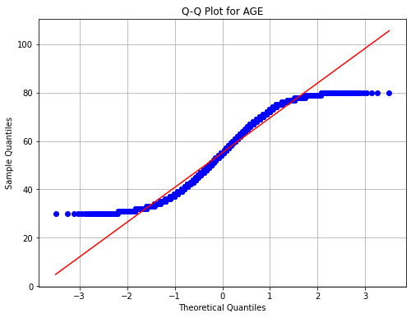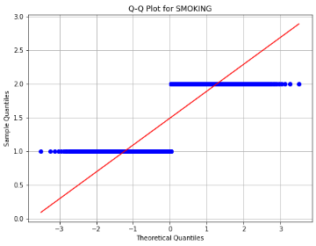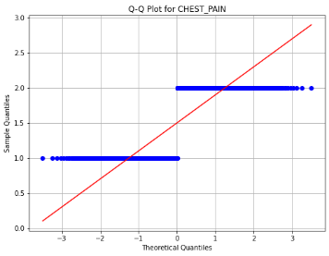

Figure 3.1: Q-Q Plot of the dataset features

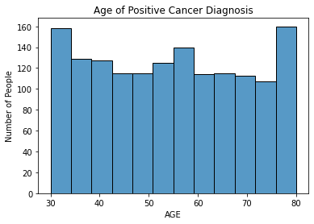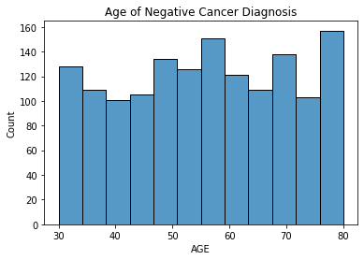

Figure 3.2: Age of patients when diagnosed with cancer

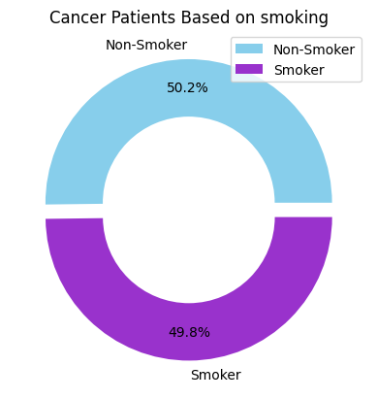
Figure 3.3: Percent of smoker’s having lung cancer

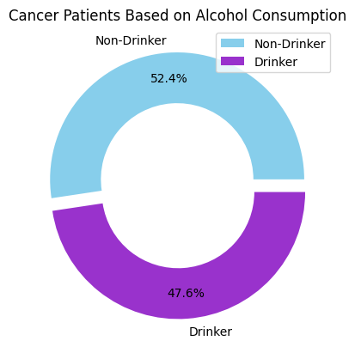

Figure 3.4: Percent of alcohol consumption having lung cancer

3.4 Correlation between Features
In this analysis, Pearson's correlation coefficient is used to explore the linear relationships between various features in the lung cancer prediction dataset. The correlation matrix reveals that most features exhibit weak to very weak correlations with each other. For instance, Age shows minimal correlation with Smoking (-0.020) and Anxiety (0.030), suggesting that age has little impact on these variables. Smoking also demonstrates weak correlations with other features, including a slight negative correlation with Anxiety (-0.056). On the other hand, Yellow Fingers has a marginally positive correlation with Swallowing Difficulty (0.018) and Alcohol Consuming (0.027).
The relationship between Anxiety and symptoms such as Shortness of Breath (-0.035) and Swallowing Difficulty (0.034) indicates a minor connection but is not strong. Chronic Disease shows a slight positive correlation with Smoking (0.046), suggesting a potential link, albeit weak, between smoking and chronic health issues. Wheezing exhibits minor positive correlations with Chronic Disease (0.022) and Fatigue (0.015), pointing to a small association with respiratory symptoms. Lastly, Gender (Male) has negligible correlations with other features, such as Age (0.011) and Smoking (-0.029), indicating that gender does not significantly influence these variables.
Overall, the analysis shows that while some features exhibit minor correlations, the relationships between most attributes are weak. This suggests that the dataset's features might interact in more complex ways or that non-linear relationships could be at play.
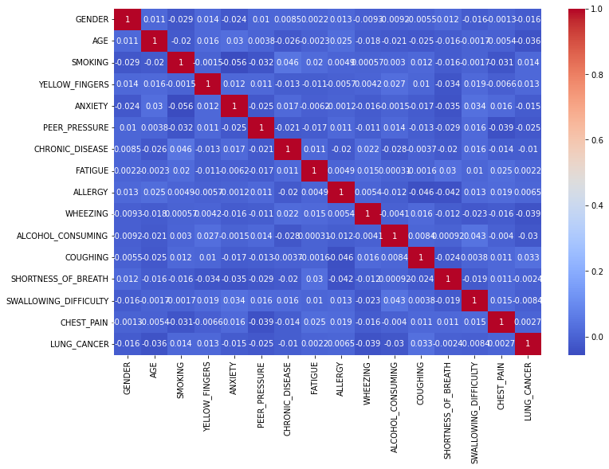
Figure 3.5: Correlation Matrix Visualization of the variable in dataset.

CHAPTER FOUR
Machine Learning Algorithm Description
4.1 Introduction
A machine learning model is a representation of an algorithm that searches through vast amounts of data to look for patterns or forecast the future. The mathematical sectors of artificial intelligence are machine learning (ML) models, which are supplied by data. For this purpose, classification methods such as Logistic Regression Classification, Support Vector Machine Classification, Random Forest Classification, Neural networks, Gradient Boosting Classification.
4.2 Logistic Regression
Logistic regression is a supervised machine learning algorithm used for classification tasks where the goal is to predict the probability that an instance belongs to a given class or not. Logistic regression is a statistical algorithm which analyze the relationship between two data factors. The article explores the fundamentals of logistic regression, it’s types and implementations [20].
How does Logistic Regression work?
The logistic regression model transforms the linear regression function continuous value output into categorical value output using a sigmoid function, which maps any real-valued set of independent variables input into a value between 0 and 1. This function is known as the logistic function [20].
Mathematical Formulation:
Given a set of input features X={x1,x2,…,xn}, the logistic regression model estimates the probability P(y=1|x) of a particular class y (for binary classification). The core of logistic regression is a linear combination of input features:
z=0+1x1+…+nxn
To map this linear combination to a probability, the logistic regression model uses the sigmoid function:
z=11+e-z
Thus the probability P(y=1|x) is:
Px =oz.=11+e-(0+1x1+…+nxn)
Where:
- P(y=1|x) is the predicted probability that the output y is 1 (the positive class).
- 0 is the intercept (bias term).
- 1,…,n are the coefficients corresponding to each feature x1,x2,…,xn
- e is Euler's number, and the sigmoid function ensures that the output is between 0 and 1.
The model predicts class labels by applying a threshold (usually 0.5) to the probability:
y={1, if P(y=1|X)≥0.5 0, if PX<0.5

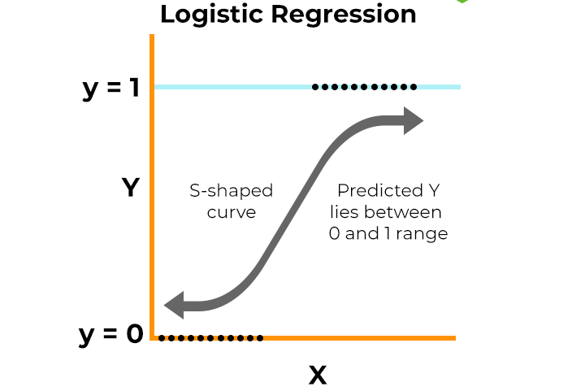
Figure 4.1 Logistic Regression

Loss Function and Optimization:
Logistic regression is optimized using the log-likelihood function, which is derived from the probability estimates. For N observations, the log-likelihood function is given by:
L=i=1N[yilog⁡(PXi)+1-yilog 1-PXi ]
The goal is to maximize the log-likelihood function, or equivalently, minimize the negative log-likelihood, which is done using optimization techniques like gradient descent to estimate the coefficients .

4.3. Support Vector Machine
A support vector machine (SVM) is a machine learning algorithm that uses supervised learning models to solve complex classification, regression, and outlier detection problems by performing optimal data transformations that determine boundaries between data points based on predefined classes, labels, or outputs. SVMs are widely adopted across disciplines such as healthcare, natural language processing, signal processing applications, and speech & image recognition fields.
Technically, the primary objective of the SVM algorithm is to identify a hyperplane that distinguishably segregates the data points of different classes. The hyperplane is localized in such a manner that the largest margin separates the classes under consideration.
The support vector representation is shown in the figure below:
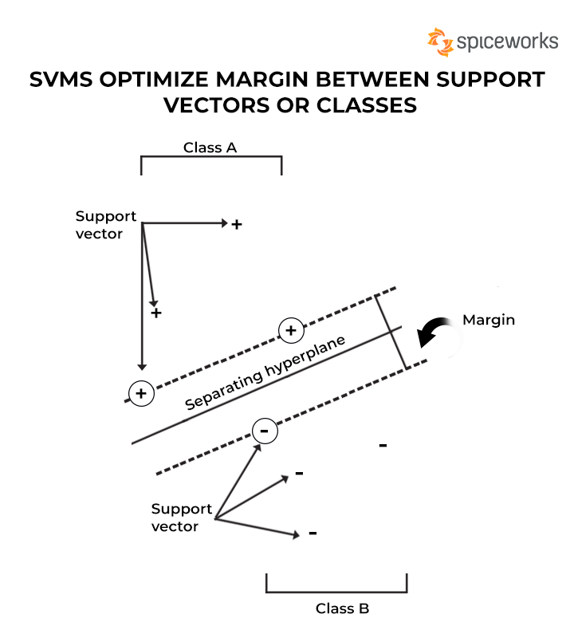
Figure 4.2 SVMs Optimize Margin Between Support Vectors or Classes

As seen in the above figure, the margin refers to the maximum width of the slice that runs parallel to the hyperplane without any internal support vectors. Such hyperplanes are easier to define for linearly separable problems; however, for real-life problems or scenarios, the SVM algorithm tries to maximize the margin between the support vectors, thereby giving rise to incorrect classifications for smaller sections of data points [21].
4.4. Random Forest Algorithm
The Random Forest algorithm is a robust machine learning method based on tree-based models. It generates multiple decision trees during the training process, each using a random subset of the dataset and selecting a random set of features at each split. This randomness increases diversity among the trees, reducing overfitting and enhancing overall prediction accuracy.
During prediction, the algorithm combines the outputs from all trees, either through voting for classification tasks or averaging for regression tasks. This collective approach, drawing insights from multiple trees, delivers stable and accurate results. Random Forests are widely used for both classification and regression tasks due to their effectiveness in handling complex data, minimizing overfitting, and producing reliable predictions across various domains [22].

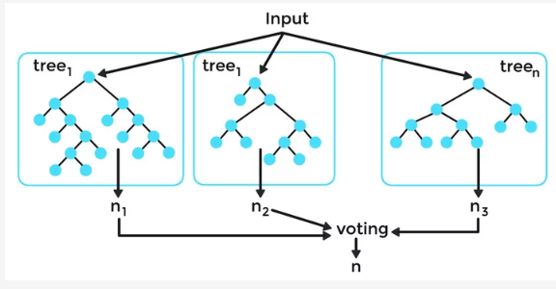
Figure 4.3 Random Forest Algorithm
How Does Random Forest Work?
Ensemble of Decision Trees: Random Forest utilizes ensemble learning by constructing multiple decision trees, where each tree acts as an independent expert focusing on different aspects of the data. Since these trees work independently, the model minimizes the risk of being overly influenced by the errors or biases of any single tree, resulting in better performance.
Random Feature Selection: To encourage diversity among the decision trees, Random Forest randomly selects a subset of features at each split during the training process. This ensures that each tree has a unique perspective on the data, preventing over-reliance on a specific feature and promoting varied predictions across the ensemble.
Bootstrap Aggregating (Bagging): A core technique of Random Forest is bagging, which involves creating multiple bootstrap samples from the original dataset. These samples are generated by random sampling with replacement, meaning some data points may be repeated while others are omitted. Each tree is trained on a different subset, introducing variability and enhancing the model's robustness.
Decision Making and Voting: In the prediction phase, each decision tree makes its own prediction. For classification tasks, the final prediction is determined by majority voting, where the most common prediction among the trees is selected. In regression tasks, the final prediction is the average of all the trees' predictions. This voting mechanism ensures a balanced and collective decision-making process, improving the model’s accuracy and stability [22].

4.5 Neural networks
Neural networks learn and make decisions by processing data through neurons, which use activation functions to handle inputs and produce outputs. The connections between neurons, including weights and biases, control how information moves through the network. During the learning process, the network adjusts these weights and biases based on performance in various simulations. As a result, the network improves its ability to handle different tasks by adapting its responses according to new data and situations [23].
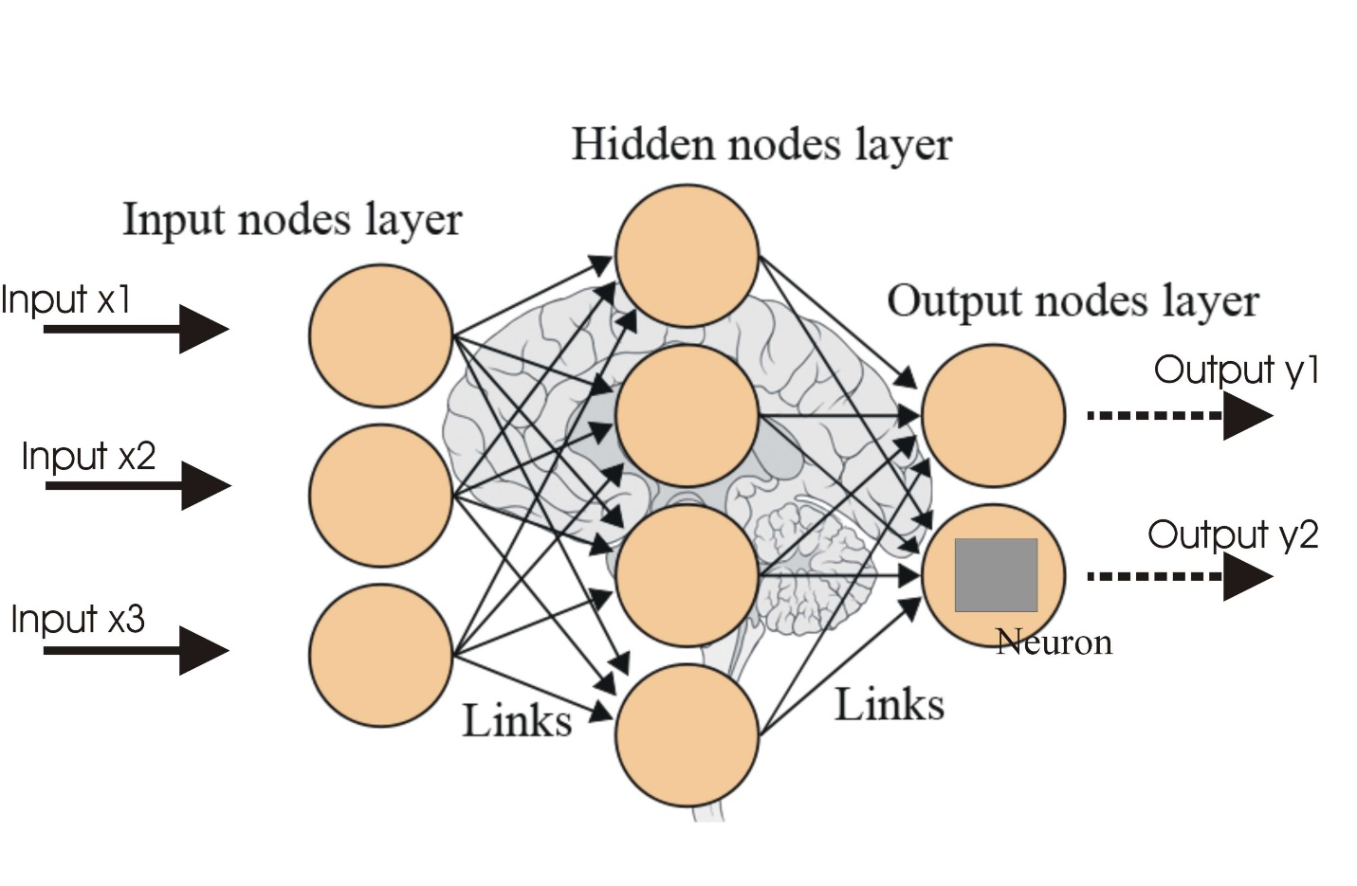
Figure 4.4 Neural networks [25]

4.6 XG Boost
"Extreme Gradient Boosting," is an optimized gradient boosting library designed for scalable and efficient training of machine learning models. It uses an ensemble method that combines multiple weak learners to create a stronger predictive model. XGBoost has gained popularity due to its ability to handle large datasets and deliver top-tier performance in tasks like classification and regression.
A standout feature of XG Boost is its efficient management of missing data, reducing the need for extensive pre-processing. Additionally, it supports parallel processing, enabling faster training on large datasets. XG Boost is widely used in various applications, such as Kaggle competitions, recommendation systems, and click-through rate prediction. Its high customizability allows users to fine-tune model parameters for optimal performance.
Originally developed by researchers at the University of Washington, XG Boost is written in C++ and designed to enhance the training process for gradient boosting models [24].
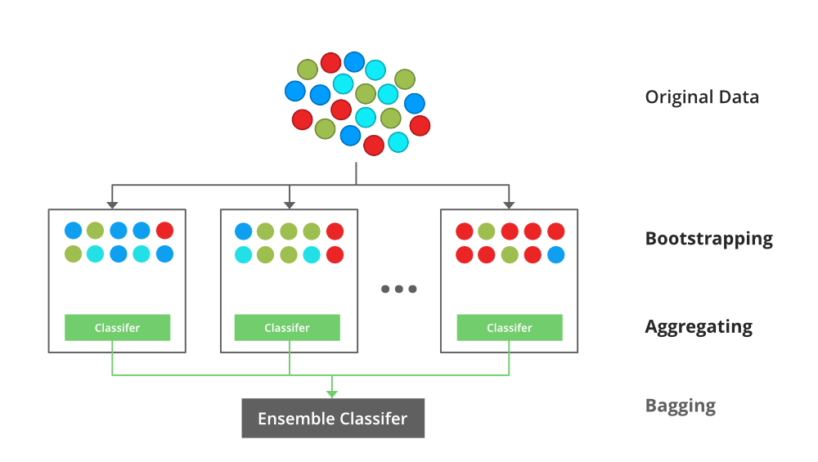
Figure 4.5 XG Boost
4.7 Model Evaluation
Confusion Matrix
A confusion matrix is a matrix that summarizes the performance of a machine learning model on a set of test data. It is a means of displaying the number of accurate and inaccurate instances based on the model’s predictions. It is often used to measure the performance of classification models, which aim to predict a categorical label for each input instance.The matrix displays the number of instances produced by the model on the test data.

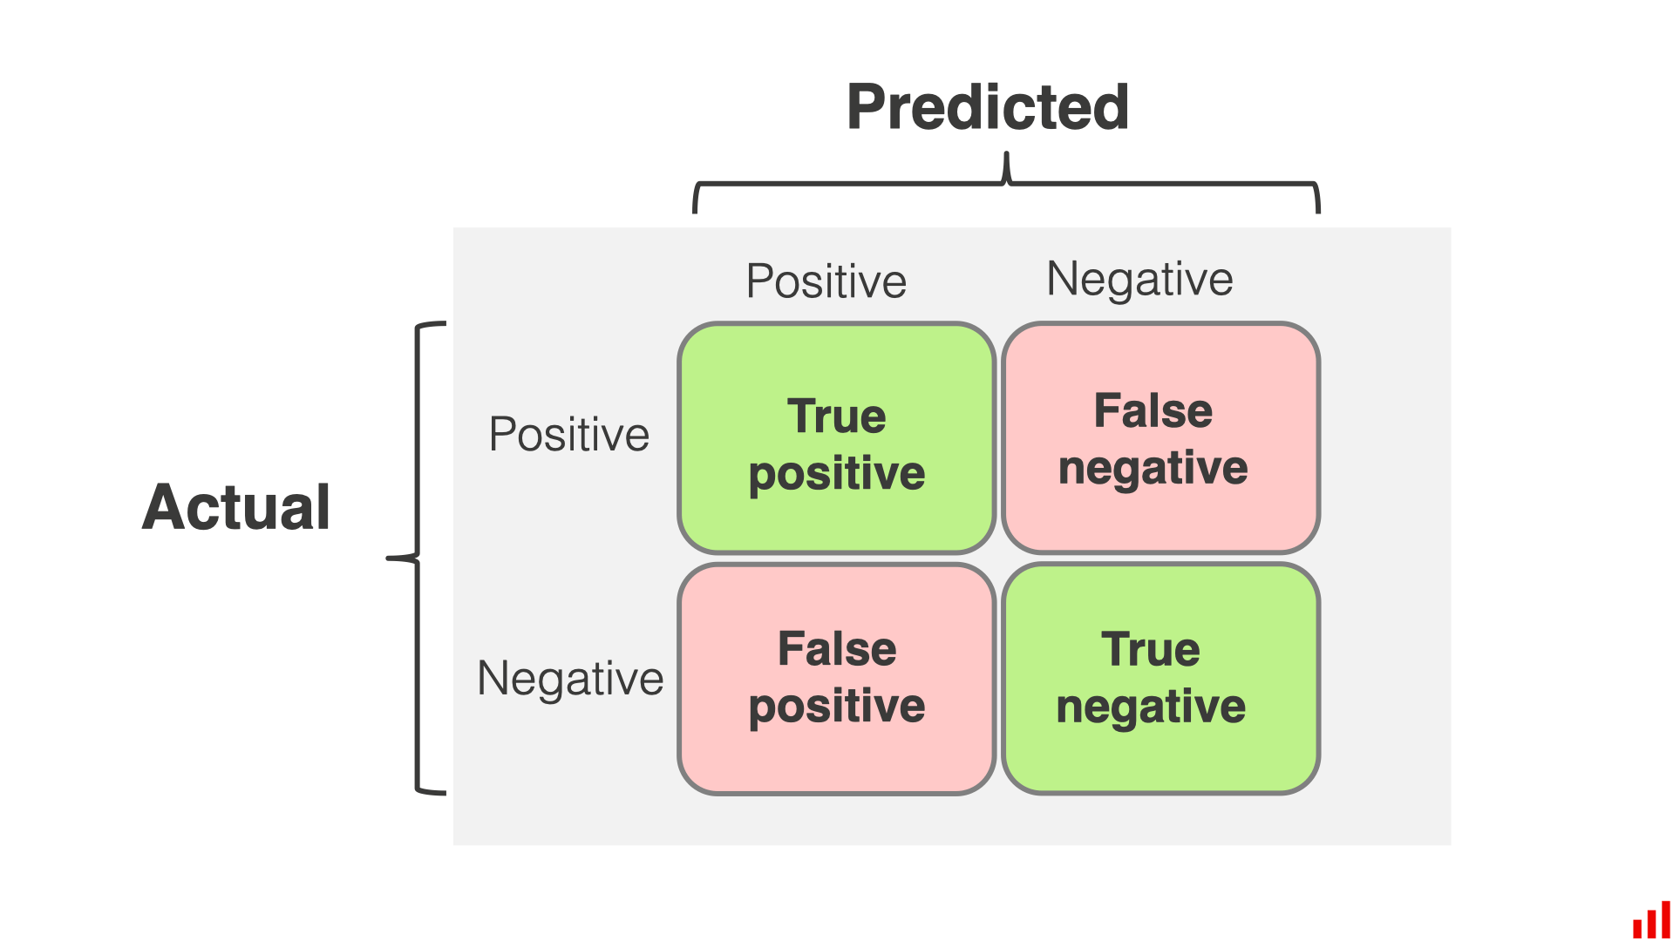
Figure 4.6 Confusion Matrix
- True Positive (TP): The model correctly predicted a positive outcome (the actual outcome was positive).
- True Negative (TN): The model correctly predicted a negative outcome (the actual outcome was negative).
- False Positive (FP): The model incorrectly predicted a positive outcome (the actual outcome was negative). Also known as a Type I error.
- False Negative (FN): The model incorrectly predicted a negative outcome (the actual outcome was positive). Also known as a Type II error.
1. Accuracy
Accuracy is used to measure the performance of the model. It is the ratio of Total correct instances to the total instances.
Accuracy=TP+TNTP+TN+FP+FN
2. Precision
Precision is a measure of how accurate a model’s positive predictions are. It is defined as the ratio of true positive predictions to the total number of positive predictions made by the model.
Precision=TPTP+FP
3. Recall
Recall measures the effectiveness of a classification model in identifying all relevant instances from a dataset. It is the ratio of the number of true positive (TP) instances to the sum of true positive and false negative (FN) instances.
Recall=TPTP+FN
4. F1-Score
F1-score is used to evaluate the overall performance of a classification model. It is the harmonic mean of precision and recall.
F1-Score=2*TP2*TP+FP+FN

4.8 Area Under the ROC Curve (AUC)
The Area Under the ROC Curve (AUC) is a widely used evaluation metric in machine learning and binary classification tasks. It measures the performance of a classification model by assessing its ability to discriminate between positive and negative classes across different classification thresholds.
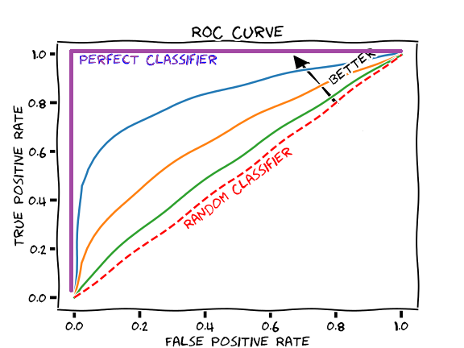
Figure 4.7 Area Under the ROC Curve (AUC) [26]

The ROC (Receiver Operating Characteristic) curve is a graphical representation of the true positive rate (TPR) against the false positive rate (FPR) as the classification threshold varies. The AUC is the area under this curve, ranging from 0 to 1. A higher AUC value indicates better discrimination and predictive performance of the model.
Here are some key aspects and benefits of AUC:
- Performance Measure: AUC provides a comprehensive evaluation of a binary classification model's performance by considering the entire range of classification thresholds. It captures the model's ability to correctly classify positive instances as positive (TPR) while minimizing false positives (FPR).
- Robustness to Imbalanced Data: AUC is less sensitive to imbalanced datasets, where one class dominates the other. It is a suitable metric when the positive and negative class instances are unevenly distributed, as it focuses on the relative ranking of predictions rather than the absolute values.
- Threshold Independence: AUC is independent of the choice of classification threshold. It considers the model's performance across all possible thresholds, providing a summary measure of its classification power. This is particularly useful when the optimal threshold is unknown or can vary based on the specific application.
- Model Comparison: AUC allows for straightforward and meaningful comparison of different models. Higher AUC values indicate better discrimination between classes, enabling researchers and practitioners to select the most effective model for a particular task.
- Interpretability: AUC has an intuitive interpretation. A model with an AUC of 0.5 performs no better than random guessing, while an AUC of 1.0 represents a perfect classification model.
It's important to note that while AUC is a valuable metric, it may not always provide a complete picture of a model's performance. Additional evaluation measures, such as precision, recall, accuracy, and F1 score, may be necessary to assess different aspects of the classification task, depending on the specific context and requirements.

Chapter Five
Data Analysis and Results Discussion
5.1 Logistic Regression Results
Interpretation of Logistic Regression Results
Table 5.1: Overall Accuracy of Logistic Regression results
Overall Accuracy
Training Accuracy | 0.5396
Testing Accuracy | 0.5167

The model's accuracy is slightly above 50% for both training and testing sets. This suggests that the model is performing only marginally better than random guessing (which would be 50% for a binary classification task).
Classification Report:
Table 5.2: Classification Report of Logistic Regression (Training Set)
Classification Report (Training Set)

Class | Precision | Recall | F1-score | Support
NO | 0.54 | 0.48 | 0.50 | 1180
YES | 0.54 | 0.60 | 0.57 | 1220
accuracy | - | - | 0.54 | 2400
macro avg | 0.54 | 0.54 | 0.54 | 2400
weighted avg | 0.54 | 0.54 | 0.54 | 2400

The model shows a precision of 0.54 for both "NO" and "YES," with better recall for "YES" (0.60) compared to "NO" (0.48). The F1-scores are 0.50 for "NO" and 0.57 for "YES," indicating moderate performance. With an overall accuracy of 0.54, the model performs slightly better than random guessing. The macro and weighted averages also reflect this moderate performance. Improving the model might require parameter tuning, trying different algorithms, or enhancing data preprocessing.
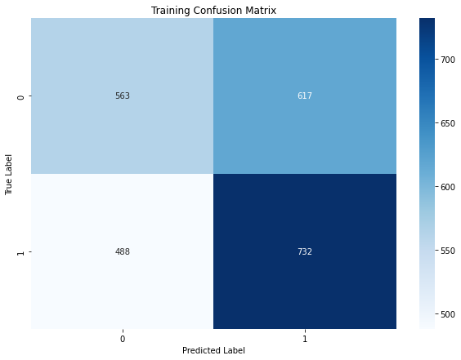
Figure 5.1: Training confusion matrix of Logistic Regression
The confusion matrix shows that the model has 732 true positives, 563 true negatives, 617 false positives, and 488 false negatives. With an accuracy of about 62.9%, the model correctly classifies a majority of cases, but it struggles with false positives and false negatives. Precision is around 54.1%, recall is 59.9%, and the F1-score is 56.9%, indicating moderate performance. Improvements could focus on reducing these misclassifications to enhance overall accuracy.
Testing Classification Report of Logistic Regression:
Table 5.3: Classification Report of Logistic Regression (Testing Set)
Testing Classification Report
Class | Precision | Recall | F1-Score | Support
NO | 0.52 | 0.48 | 0.50 | 302
YES | 0.51 | 0.56 | 0.53 | 298
Accuracy |  |  | 0.52 | 600
Macro avg | 0.52 | 0.52 | 0.52 | 600
Weighted avg | 0.52 | 0.52 | 0.52 | 600

The classification report reveals that the model performs moderately, with an overall accuracy of 52%. For class "NO," it has a precision of 52% and a recall of 48%, indicating it correctly identifies about half of the "NO" cases but misses a significant portion. For class "YES," precision is slightly lower at 51%, but recall is better at 56%, showing a better ability to identify "YES" cases. Both classes have similar F1-scores around 0.52, reflecting balanced but modest performance. Overall, the model shows consistent but limited effectiveness in distinguishing between the two classes.

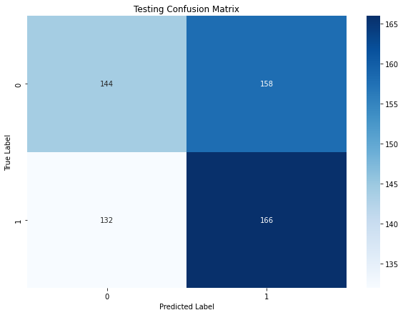
Figure 5.2: Testing confusion matrix of Logistic Regression
The confusion matrix reveals that the model correctly classified 166 positive cases and 144 negative cases. However, it misclassified 158 negative cases as positive and 132 positive cases as negative. With an accuracy of approximately 59.7%, the model shows reasonable performance but has notable misclassifications. Precision is about 51.2%, recall is 55.7%, and the F1-score is 53.4%. These metrics suggest that while the model performs fairly well, there is room for improvement, especially in reducing false positives and false negatives.

5.2 Support Vector Machine Results
Interpretation of Support Vector Machine
Table 5.4: Classification Report of Support Vector Machine
Overall Accuracy
Training Accuracy | 0.5154
Testing Accuracy | 0.5067
The model shows modest performance with a training accuracy of 51.5% and a testing accuracy of 50.7%. The slight drop in accuracy from training to testing suggests that the model may not generalize well to new data, indicating potential issues with overfitting or a need for improvement in its predictive power.
Classification Report
Table 5.5: Classification Report of Support Vector Machine (Training Set)
Classification Report (Training Set)

Class | Precision | Recall | F1-score | Support
NO | 0.51 | 0.42 | 0.46 | 1180
YES | 0.52 | 0.60 | 0.56 | 1220
Accuracy |  |  | 0.52 | 2400
Macro avg | 0.51 | 0.51 | 0.51 | 2400
Weighted avg | 0.51 | 0.52 | 0.51 | 2400

The table shows that the model performs similarly for both classes ("NO" and "YES"). For class "NO," it has a precision of 51%, meaning 51% of predicted "NO" cases are correct. However, recall is lower at 42%, indicating it misses many actual "NO" cases. For class "YES," the model has a slightly better recall at 60%, meaning it identifies more "YES" cases correctly, with a precision of 52%. The overall accuracy is 52%, and the macro and weighted averages are also around 51%, reflecting balanced but modest performance across both classes.
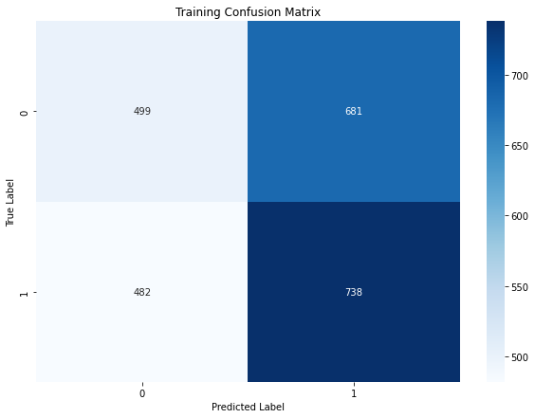
Figure 5.3: Training confusion matrix of Support Vector Machine
The confusion matrix indicates that the model correctly classified 738 positive cases and 499 negative cases. However, it misclassified 681 negative cases as positive and 482 positive cases as negative. With an accuracy of around 60.7%, the model performs fairly well but has notable misclassifications. Precision is approximately 52.0%, recall is 60.4%, and the F1-score is 56.0%. These metrics highlight that while the model is effective, there is significant room for improvement in reducing false positives and false negatives.
Testing Classification Report of Support Vector Machine:
Table 5.6: Classification Report of Support Vector Machine (Testing Set)
Testing Classification Report
Class | Precision | Recall | F1-Score | Support
NO | 0.51 | 0.41 | 0.45 | 302
YES | 0.50 | 0.61 | 0.55 | 298
Accuracy |  |  | 0.51 | 600
Macro Avg | 0.51 | 0.51 | 0.50 | 600
Weighted Avg | 0.51 | 0.51 | 0.50 | 600

The table shows that for class "NO," the precision is 51%, meaning 51% of predicted "NO" cases are correct, while recall is 41%, indicating the model misses many actual "NO" cases. For class "YES," precision is 50%, and recall is 61%, meaning the model correctly identifies 61% of "YES" cases. The overall accuracy is 51%, with similar performance across both classes based on the macro and weighted averages, indicating modest model performance for the testing set.

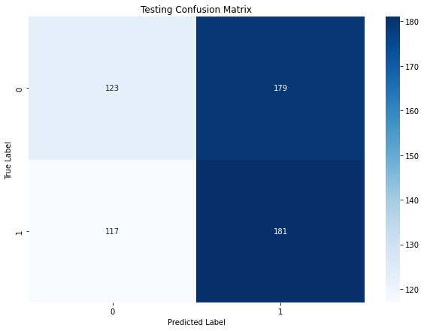
Figure 5.4: Testing confusion matrix of Support Vector Machine
The confusion matrix shows that the model correctly identified 181 positive cases and 123 negative cases. However, it also misclassified 179 negative cases as positive and 117 positive cases as negative. The model’s accuracy is around 60.6%, with a precision of about 50.3%, recall of 60.8%, and an F1-score of 55.2%. These metrics suggest that while the model performs reasonably well, there is considerable room for improvement, particularly in reducing misclassifications of both positive and negative cases.
  - Interpretation of Random Forest Algorithm Results
- Table 5.7: Classification Report of Random Forest Algorithm
Overall Accuracy
Training Accuracy | 0.9996
Testing Accuracy | 0.5033

The Random Forest model shows signs of overfitting, with a near-perfect training accuracy (99.96%) but poor testing accuracy (50.33%), close to random guessing. This large gap suggests the model has memorized the training data, including noise, and is unable to generalize to unseen data. To improve, techniques like regularization, pruning, cross-validation, or reducing the number of features can help. Additionally, increasing the dataset and focusing on feature selection may boost the model's performance on new data.
Classification Report of Random Forest Algorithm
Table 5.8: Classification Report of Random Forest Algorithm (Training Set)
Classification Report (Training Set)

Class | Precision | Recall | F1-score | Support
NO | 1.00 | 1.00 | 1.00 | 1180
YES | 1.00 | 1.00 | 1.00 | 1220
Accuracy |  |  | 1.00 | 2400
Macro Avg | 1.00 | 1.00 | 1.00 | 2400
Weighted Avg | 1.00 | 1.00 | 1.00 | 2400

The Classification Report for the Training Set of the Random Forest algorithm shows perfect performance. Both classes ("NO" and "YES") have a precision, recall, and F1-score of 1.00, indicating flawless prediction on the training data. The overall accuracy is also 1.00, meaning the model has perfectly classified all training samples. This suggests the model has likely overfit the training data, as it performs exceptionally well on the data it has seen but may not generalize to new data.

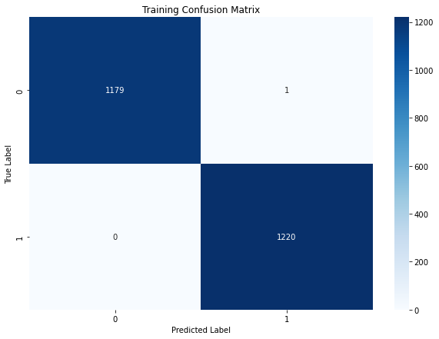

Figure 5.5: Training confusion matrix of Random Forest algorithm
The confusion matrix reveals that the model correctly identified 1,220 positive cases and 1,179 negative cases. It made only 1 false positive and no false negatives, indicating almost perfect classification on the training dataset. This exceptional performance suggests that the model is highly effective on this data. However, to confirm that the model generalizes well to new, unseen data, it is crucial to evaluate its performance on a separate testing dataset.

Testing Classification Report of Random Forest Algorithm:
Table 5.9: Classification Report of Random Forest Algorithm (Testing Set)
Testing Classification Report
NO | 0.51 | 0.48 | 0.49 | 302
YES | 0.50 | 0.53 | 0.51 | 298
Accuracy |  |  | 0.50 | 600
Macro Avg | 0.50 | 0.50 | 0.50 | 600
Weighted Avg | 0.50 | 0.50 | 0.50 | 600

The Testing Classification Report shows that the Random Forest model performs poorly on new data. With an accuracy of 0.50, the model’s precision, recall, and F1-score for both classes ("NO" and "YES") are around 0.50, which is close to random guessing. This indicates that the model struggles to generalize beyond the training data, reflecting significant overfitting.

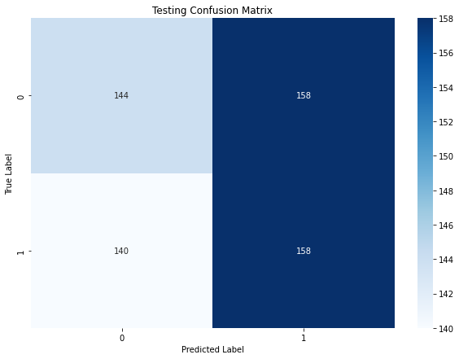
Figure 5.6: Testing confusion matrix of Random Forest algorithm

The confusion matrix indicates that the model correctly classified 158 positive cases and 144 negative cases. However, it also made 158 false positive predictions and 140 false negatives. This results in an accuracy of approximately 55.6%, with a precision of about 50.0%, recall of 53.0%, and an F1-score of 51.4%. These metrics suggest that while the model performs reasonably, there is a notable level of misclassification. Further analysis and model adjustments could help improve performance, especially in reducing false positives and false negatives.

5.4 Neural networks MLP Classifier Results:
Interpretation of Neural networks MLP Classifier
Table 5.10: Classification Report of Neural networks MLP Classifier
Overall Accuracy
Training Accuracy | 0.5288
Testing Accuracy | 0.5067

The neural network achieved a training accuracy of 0.5288 and a testing accuracy of 0.5067. This means that during the training phase, the network correctly predicted about 52.88% of the training data. However, when tested on new, unseen data, its accuracy slightly decreased to 50.67%. This drop in accuracy from training to testing suggests that the network might be overfitting to the training data, meaning it has learned to perform well on the data it was trained on but struggles to generalize to new data. Overall, the network shows modest performance and may benefit from further tuning or additional data to improve its ability to generalize.

Classification Report of Neural networks
Table 5.11: Classification Report of Neural networks MLP Classifier (Training Set)
Classification Report (Training Set)

Class | Precision | Recall | F1-score | Support
NO | 0.53 | 0.39 | 0.45 | 1180
YES | 0.53 | 0.67 | 0.59 | 1220
Accuracy |  |  | 0.53 | 2400
Macro Avg | 0.53 | 0.53 | 0.52 | 2400
Weighted Avg | 0.53 | 0.53 | 0.52 | 2400

The neural network's training performance shows an overall accuracy of 53%. For class NO, the precision is 53% and recall is 39%, indicating moderate accuracy in predictions but lower effectiveness in identifying all actual NO cases. For class YES, the precision remains at 53%, but the recall improves to 67%, showing better performance in identifying YES cases. The F1-scores reflect similar patterns, with the YES class performing better. The macro and weighted averages are consistent, highlighting balanced but moderate overall performance. There is room for improvement, especially in the recall for the NO class.

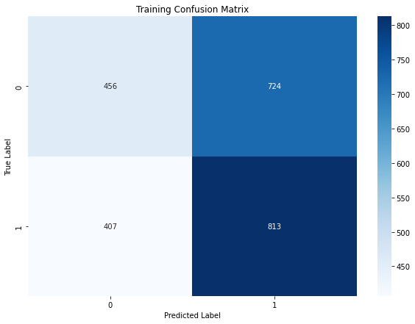
Figure 5.7: Training confusion matrix of Neural networks MLP Classifier
The confusion matrix shows that the model correctly identified 813 positive cases and 456 negative cases. However, it made 724 false positive predictions and 407 false negatives. This results in an accuracy of approximately 58.4%, with a precision of about 52.9%, recall of 66.7%, and an F1-score of 59.2%. While the model performs reasonably well, there is a notable number of misclassifications, particularly in false positives and false negatives. Improving these metrics would enhance the model’s overall performance.
Testing Classification Report Testing Set:
Table 5.12: Classification Report of Neural networks MLP Classifier (Testing Set)
Testing Classification Report
NO | 0.51 | 0.38 | 0.44 | 302
YES | 0.50 | 0.64 | 0.56 | 298
Accuracy |  |  | 0.51 | 600
Macro Avg | 0.51 | 0.51 | 0.50 | 600
Weighted Avg | 0.51 | 0.51 | 0.50 | 600

On the testing set, the neural network achieved an accuracy of 51%. For class NO, the precision is 51% and recall is 38%, indicating moderate precision but lower effectiveness in identifying all NO instances. For class YES, precision is 50% and recall is 64%, showing better performance in detecting YES cases. The F1-scores are slightly better for YES, reflecting improved balance between precision and recall for that class. Overall, the model performs modestly, with similar macro and weighted averages, suggesting a need for further improvement, especially in the detection of NO cases.

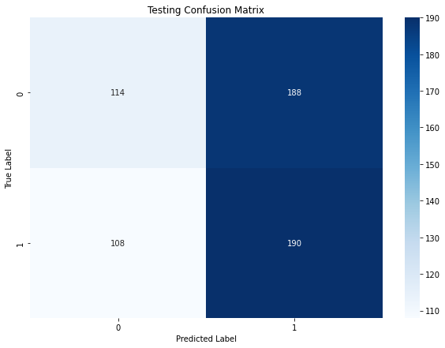
Figure 5.8: Testing confusion matrix of Neural networks MLP Classifier

The confusion matrix indicates that the model correctly classified 190 positive cases and 114 negative cases. It also misclassified 188 negative cases as positive and 108 positive cases as negative. The accuracy of the model is approximately 55.8%, with a precision of about 50.5%, recall of 63.0%, and an F1-score of 56.2%. These metrics highlight that while the model performs decently, there is a significant level of misclassification, suggesting room for improvement in both precision and recall.

5.5 Extreme Gradient Boosting Results:
Interpretation of Extreme Gradient Boosting
Table 5.13: Classification Report of Extreme Gradient Boosting
Overall Accuracy
Training Accuracy | 0.9838
Testing Accuracy | 0.4883

The Extreme Gradient Boosting (XGBoost) model shows a training accuracy of 0.9838 (98.38%) and a testing accuracy of 0.4883 (48.83%).This large difference suggests that the model is likely overfitting. It performs very well on the training data but fails to generalize to the testing data, indicating the model may be overly complex or tuned too much to the training set. Reducing complexity or regularizing the model might help improve its performance on unseen data.
Classification Report of Extreme Gradient Boosting
Table 5.14: Classification Report of Extreme Gradient Boosting (Testing Set)
Classification Report (Training Set)

Class | Precision | Recall | F1-Score | Support
No | 0.99 | 0.98 | 0.98 | 1180
Yes | 0.98 | 0.99 | 0.98 | 1220
Accuracy |  |  | 0.98 | 2400
Macro Avg | 0.98 | 0.98 | 0.98 | 2400
Weighted Avg | 0.98 | 0.98 | 0.98 | 2400

The Extreme Gradient Boosting model performs exceptionally well on the training set, with 98-99% precision, recall, and F1-scores for both classes, and an overall accuracy of 98%. However, the high training performance suggests overfitting, as the model fails to generalize to the test data.
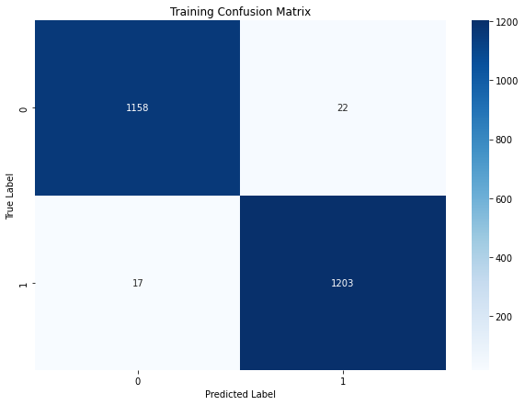
Figure 5.9: Training confusion matrix of Extreme Gradient Boosting
The confusion matrix shows that the model correctly classified 1,203 positive cases and 1,158 negative cases. It made only 22 false positive and 17 false negative predictions. With such few misclassifications, the model demonstrates exceptional performance on the training dataset. However, to confirm that it generalizes well to new, unseen data, it is essential to evaluate its performance on a separate testing dataset.

Testing Classification Report of Extreme Gradient Boosting:
Table 5.15: Classification Report of Extreme Gradient Boosting (Testing Set)
Testing Classification Report
Class | Precision | Recall | F1-Score | Support
No | 0.49 | 0.45 | 0.47 | 302
Yes | 0.49 | 0.53 | 0.51 | 298
Accuracy |  |  | 0.49 | 600
Macro Avg | 0.49 | 0.49 | 0.49 | 600

The testing classification report for Extreme Gradient Boosting shows poor performance, with both classes ("No" and "Yes") having precision, recall, and F1-scores around 0.49-0.51. The overall accuracy is 49%, meaning the model correctly predicts the class for only about half of the test data. The low scores indicate that the model is not generalizing well to the testing set, confirming issues with overfitting observed earlier.

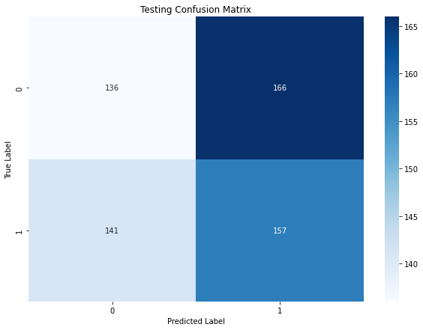
Figure 5.10: Testing confusion matrix of Extreme Gradient Boosting

The confusion matrix reveals that the model correctly classified 157 positive cases and 136 negative cases. However, it made 166 false positive predictions and 141 false negatives. This results in an accuracy of approximately 55.4%, with a precision of about 48.6%, recall of 52.7%, and an F1-score of 50.6%. These metrics indicate that while the model performs reasonably, there are notable misclassifications that suggest potential areas for improvement in both precision and recall.

5.6 Model Comparison and Comparative Analysis:
Table 6.1: Comparison of Different Model
Model | Training Accuracy | Testing Accuracy | Precision (Train) | Recall (Train) | F1-score (Train) | Precision (Test) | Recall (Test) | F1-score (Test) | Overfitting (Δ Accuracy)
Logistic Regression | 0.5396 | 0.5167 | 0.54 (NO), 0.54 (YES) | 0.48 (NO), 0.60 (YES) | 0.50 (NO), 0.57 (YES) | 0.52 (NO), 0.51 (YES) | 0.48 (NO), 0.56 (YES) | 0.50 (NO), 0.53 (YES) | 0.0229
SVM | 0.5154 | 0.5067 | 0.51 (NO), 0.52 (YES) | 0.42 (NO), 0.60 (YES) | 0.46 (NO), 0.56 (YES) | 0.51 (NO), 0.50 (YES) | 0.41 (NO), 0.61 (YES) | 0.45 (NO), 0.55 (YES) | 0.0087
Random Forest | 0.9996 | 0.5033 | 1.00 (NO, YES) | 1.00 (NO, YES) | 1.00 (NO, YES) | 0.51 (NO), 0.50 (YES) | 0.48 (NO), 0.53 (YES) | 0.49 (NO), 0.51 (YES) | 0.4963
Neural Network (MLP) | 0.5288 | 0.5067 | 0.53 (NO), 0.53 (YES) | 0.39 (NO), 0.67 (YES) | 0.45 (NO), 0.59 (YES) | 0.51 (NO), 0.50 (YES) | 0.38 (NO), 0.64 (YES) | 0.44 (NO), 0.56 (YES) | 0.0221
XG Boost | 0.9838 | 0.4883 | 0.99 (NO), 0.98 (YES) | 0.98 (NO), 0.99 (YES) | 0.98 (NO, YES) | 0.49 (NO, YES) | 0.45 (NO), 0.53 (YES) | 0.47 (NO), 0.51 (YES) | 0.4955

Logistic Regression and SVM are the most stable models in terms of generalization, while Random Forest and XGBoost are overfitted. The Neural Network shows potential but needs further optimization. To improve overall model performance, efforts should focus on reducing overfitting, increasing recall for the "NO" class, and possibly enhancing feature selection and data preprocessing.

ROC Curve:

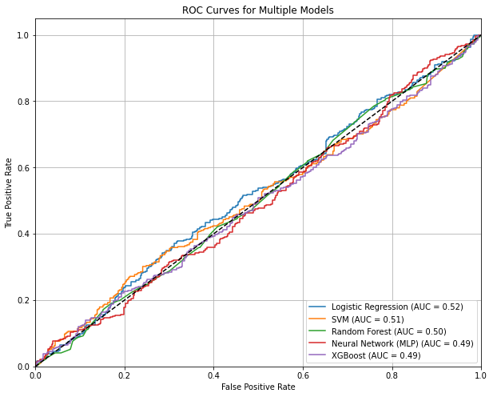

Figure 6.1: ROC Curve of Logistic Regression, SVM, Random Forest, Neural Network (MLP) and XG Boost using all Features.

The ROC curve analysis reveals that Logistic Regression has the highest AUC at 0.52, indicating it performs slightly better than other models. SVM follows with an AUC of 0.51, while Random Forest and both Neural Network (MLP) and XGBoost show lower performance with AUCs around 0.50 and 0.49, respectively. Despite Logistic Regression's marginally better performance, all models exhibit limited discriminative power, as none significantly outperform random guessing. Therefore, while Logistic Regression appears to be the most suitable model, further exploration or model refinement may be necessary to improve classification accuracy.

Chapter 6
Conclusion and Recommendations

6.1 Conclusion
This study aimed to evaluate the performance of several machine learning models for predicting smoking behavior among patients based on attributes like gender and age. The models assessed include Logistic Regression, Support Vector Machines (SVM), Random Forest, Neural Networks (MLP Classifier), and Extreme Gradient Boosting (XGBoost). Each model was evaluated using key metrics such as accuracy, precision, recall, and F1-score, with special emphasis on overfitting and generalization capabilities.
Across the models, Logistic Regression and SVM demonstrated the most stable performance, with minimal overfitting and balanced precision and recall, achieving testing accuracies of around 50-53%. Despite being basic classifiers, their moderate generalization to unseen data suggests they can serve as reliable baselines for binary classification tasks.
In contrast, Random Forest and XGBoost, while powerful models, exhibited severe overfitting. Both models achieved near-perfect accuracy on the training data but performed poorly on the test data, with testing accuracies barely above 50%. This indicates the need for better regularization and tuning to enhance their ability to generalize.
The Neural Network (MLP Classifier) showed moderate performance, with small gaps between training and testing accuracies. However, its overall effectiveness remained limited, particularly in distinguishing between the "NO" and "YES" classes, where recall for the "NO" class was consistently lower.
One key observation is the difficulty across all models in effectively predicting "NO" cases, with significantly lower recall for this class. This suggests that the dataset or feature selection may not provide sufficient signals to differentiate between the classes.

In summary, while none of the models demonstrated exceptional predictive capabilities, Logistic Regression and SVM proved to be the most stable. Random Forest and XGBoost require regularization to mitigate overfitting, and the Neural Network has potential but needs further optimization. Future work should focus on enhancing feature selection, addressing class imbalance, and exploring advanced techniques to improve model performance for this classification task.
6.2 Recommendations for Future Work
- Feature Engineering: Creating new features or transforming existing ones (e.g., via PCA or dimensionality reduction techniques) may enhance the models’ ability to distinguish between classes.
- Regularization and Hyperparameter Tuning: For models like Random Forest and XGBoost, introducing regularization methods and fine-tuning hyperparameters may help reduce overfitting and improve generalization.
- Cross-Validation: Using cross-validation techniques (e.g., K-fold) can provide a more reliable estimate of model performance and help avoid overfitting by training on multiple subsets of the data.
- Ensemble Methods: Combining multiple classifiers (e.g., stacking Logistic Regression, SVM, and Random Forest) could result in better overall performance by leveraging the strengths of each model.
- Handling Class Imbalance: Since the models had difficulty predicting "NO" cases, handling class imbalance (if present) via techniques like SMOTE (Synthetic Minority Over-sampling Technique) or adjusting class weights could improve recall for the minority class.
- Larger and More Diverse Dataset: Increasing the size of the dataset or incorporating more diverse features may provide better training examples for the models to learn from, enhancing overall performance.

References
- Yamini, B., Sudha, K., Nalini, M., Kavitha, G., Subramanian, R. S., & Sugumar, R. (2023, June). Predictive modelling for lung cancer detection using machine learning techniques. In 2023 8th International Conference on Communication and Electronics Systems (ICCES) (pp. 1220-1226). IEEE.
- Raoof, S. S., Jabbar, M. A., & Fathima, S. A. (2020). "Lung Cancer Prediction using Machine Learning: A Comprehensive Approach," 2020 2nd International Conference on Innovative Mechanisms for Industry Applications (ICIMIA), Bangalore, India, pp. 108-115. doi: 10.1109/ICIMIA48430.2020.9074947.
- Cai, Z., Xu, D., Zhang, Q., Zhang, J., Ngai, S. M., & Shao, J. (2015). Classification of lung cancer using ensemble-based feature selection and machine learning methods. Molecular BioSystems, 11(3), 791-800.
- Lalitha, S. (2021). An automated lung cancer detection system based on machine learning algorithm. Journal of Intelligent & Fuzzy Systems, 40(4), 6355-6364.
- Forte, G. C., Altmayer, S., Silva, R. F., Stefani, M. T., Libermann, L. L., Cavion, C. C., ... & Hochhegger, B. (2022). Deep learning algorithms for diagnosis of lung cancer: a systematic review and meta-analysis. Cancers, 14(16), 3856.
- Bharathy, S., & Pavithra, R. (2022, May). Lung cancer detection using machine learning. In 2022 International Conference on Applied Artificial Intelligence and Computing (ICAAIC) (pp. 539-543). IEEE.
- Patra, Radhanath. "Prediction of lung cancer using machine learning classifier." Computing Science, Communication and Security: First International Conference, COMS2 2020, Gujarat, India, March 26–27, 2020, Revised Selected Papers 1. Springer Singapore, 2020.
- Taher, F., et al. "An overview of lung cancer classification algorithms and their performances." IAENG International Journal of Computer Science 48.4 (2021): IJCS_48_4_19.
- Modak, Chinmoy, et al. "A Study of Lung Cancer Prediction Using Machine Learning Algorithms." 2023 3rd International Conference on Electronic and Electrical Engineering and Intelligent System (ICE3IS). IEEE, 2023.
- Hoque, Ariful, et al. "Automated detection of lung cancer using CT scan images." 2020 IEEE Region 10 Symposium (TENSYMP). IEEE, 2020.
- Khan, Razib Hayat, et al. "Enhancing Lung Cancer Diagnosis with Machine Learning Methods and Systematic Review Synthesis." 2023 8th International Conference on Electrical, Electronics and Information Engineering (ICEEIE). IEEE, 2023.
- Singh, Amit, Rakesh Kumar, and Rajul Rastogi. "Study of machine learning models for the prediction and detection of lungs cancer." 2022 11th International Conference on System Modeling & Advancement in Research Trends (SMART). IEEE, 2022.
- Paliwal, Geetanjali, and Umashankar Kurmi. "A Comprehensive Analysis of Identifying Lung Cancer via Different Machine Learning Approach." 2021 10th International Conference on System Modeling & Advancement in Research Trends (SMART). IEEE, 2021.
- Karhan, Zehra, and Taner Tunç. "Lung cancer detection and classification with classification algorithms." IOSR Journal of Computer Engineering (IOSR-JCE) 18.6 (2016): 71-7.
- Chaturvedi, Pragya, et al. "Prediction and classification of lung cancer using machine learning techniques." IOP conference series: materials science and engineering. Vol. 1099. No. 1. IOP Publishing, 2021.
- Juma, K., M. He, and Y. Zhao. "Lung cancer detection and analysis using data mining techniques, principal component analysis and artificial neural network." American Scientific Research Journal for Engineering, Technology, and Sciences (ASRJETS) 26.3 (2016): 254-265.
- Bharati, Subrato, et al. "Comparative performance analysis of different classification algorithm for the purpose of prediction of lung cancer." Intelligent Systems Design and Applications: 18th International Conference on Intelligent Systems Design and Applications (ISDA 2018) held in Vellore, India, December 6-8, 2018, Volume 2. Springer International Publishing, 2020.
- Shaikh, F. J., and D. S. Rao. "Prediction of cancer disease using machine learning approach." Materials Today: Proceedings 50 (2022): 40-47.
- Makaju, Suren, et al. "Lung cancer detection using CT scan images." Procedia Computer Science 125 (2018): 107-114.
- https://www.geeksforgeeks.org/understanding-logistic-regression/
- https://www.spiceworks.com/tech/big-data/articles/what-is-support-vector-machine/
- https://www.geeksforgeeks.org/random-forest-algorithm-in-machine-learning/
- https://www.geeksforgeeks.org/neural-networks-a-beginners-guide/
- “Lung Cancer Dataset | Kaggle. ”https://www.kaggle.com/datasets/akashnath29/lung-cancer-dataset/data (accessed . Aug 25, 2024).
- https://www.analyticsvidhya.com/blog/2016/08/evolution-core-concepts-deep-learning-neural-networks/
- https://glassboxmedicine.com/2019/02/23/measuring-performance-auc-auroc/

APPENDIX
Code
#Projection based Statistical feature extraction for stroke prediction using ML algorithm
import pandas as pd
import numpy as np
from sklearn.impute import SimpleImputer
from sklearn.preprocessing import StandardScaler
from sklearn.datasets import make_classification
from sklearn.preprocessing import MinMaxScaler
from sklearn.model_selection import train_test_split
from sklearn.linear_model import LogisticRegression
from sklearn.metrics import accuracy_score
from sklearn.metrics import confusion_matrix
from pandas import DataFrame
from sklearn.calibration import CalibratedClassifierCV
from sklearn import preprocessing
from sklearn.impute import KNNImputer
from sklearn.neighbors import KNeighborsClassifier
from sklearn.tree import DecisionTreeClassifier
from sklearn.svm import LinearSVC, SVC
from sklearn.neural_network import MLPClassifier
from sklearn.ensemble import RandomForestClassifier, GradientBoostingClassifier
from xgboost import XGBClassifier
from lightgbm import LGBMClassifier
from catboost import CatBoostClassifier
from sklearn.naive_bayes import GaussianNB
from sklearn.ensemble import StackingClassifier
from sklearn.ensemble import VotingClassifier
from sklearn.svm import SVC
import xgboost as xgb
import seaborn as sns
import matplotlib.pyplot as plt
from scipy import stats
from sklearn.decomposition import PCA
from sklearn.discriminant_analysis import LinearDiscriminantAnalysis
from sklearn.ensemble import AdaBoostClassifier
from sklearn.ensemble import GradientBoostingClassifier
from sklearn.ensemble import ExtraTreesClassifier
from sklearn.linear_model import SGDClassifier
from sklearn.datasets import make_regression
from sklearn.feature_selection import SelectKBest 53

from sklearn.feature_selection import f_regression
from sklearn.model_selection import StratifiedKFold
from sklearn.metrics import accuracy_score, f1_score
from sklearn.metrics import log_loss,roc_auc_score,precision_score,f1_score,recall_score,roc_curve,auc
from sklearn.model_selection import train_test_split
from sklearn.metrics import classification_report, confusion_matrix,fbeta_score,matthews_corrcoef
from sklearn import metrics
from sklearn.metrics import roc_auc_score, classification_report
import time
import warnings
warnings.filterwarnings(action='ignore')
# Load your dataset
df = pd.read_csv("C:/Users/use/Desktop/Research purpose/resourch/dataset.csv")

Logistic Regression
# Set the correct target column
target_column = 'LUNG_CANCER'
# Separate features and target
X = df.drop(target_column, axis=1) # Drop the target column to get features
y = df[target_column] # Select the target column
# Convert categorical features to numerical if necessary
X = pd.get_dummies(X, drop_first=True) # Example of one-hot encoding if needed
# Initialize the StandardScaler
scaler = StandardScaler()
# Fit the scaler on the entire dataset and transform it
X_scaled = scaler.fit_transform(X)
# Convert the scaled data back to a DataFrame for easier handling
X_scaled = pd.DataFrame(X_scaled, columns=X.columns)
# Split the data into training and testing sets
X_train, X_test, y_train, y_test = train_test_split(X_scaled, y, test_size=0.2, random_state=42)
# Create and train the Logistic Regression classifier
log_reg_classifier = LogisticRegression(random_state=42, max_iter=1000)
log_reg_classifier.fit(X_train, y_train)
# Function to evaluate the model
def evaluate_model(X, y, set_name, classifier):
# Make predictions
y_pred = classifier.predict(X)
# Calculate accuracy
accuracy = accuracy_score(y, y_pred)
print(f"\n{set_name} Accuracy: {accuracy:.4f}")
# Generate the classification report
class_report = classification_report(y, y_pred)
print(f"\n{set_name} Classification Report:")
print(class_report)
# Generate the confusion matrix
conf_matrix = confusion_matrix(y, y_pred)
# Plot the confusion matrix
plt.figure(figsize=(10,7))
sns.heatmap(conf_matrix, annot=True, fmt='d', cmap='Blues')
plt.title(f'{set_name} Confusion Matrix')
plt.ylabel('True Label')
plt.xlabel('Predicted Label')
plt.show()
# Evaluate on training set
evaluate_model(X_train, y_train, "Training", log_reg_classifier)
# Evaluate on testing set
evaluate_model(X_test, y_test, "Testing", log_reg_classifier)

SVM
Set the correct target column
target_column = 'LUNG_CANCER'
# Separate features (excluding the target column)
X = df.drop(target_column, axis=1)
y = df[target_column]
# Convert categorical features to numerical if necessary
X = pd.get_dummies(X, drop_first=True)
# Split the data into training and testing sets
X_train, X_test, y_train, y_test = train_test_split(X, y, test_size=0.2, random_state=42)
# Create and train the SVM classifier
svm_classifier = SVC(kernel='rbf', random_state=42)
svm_classifier.fit(X_train, y_train)
def evaluate_model(X, y, set_name):
# Make predictions
y_pred = svm_classifier.predict(X)
# Calculate accuracy
accuracy = accuracy_score(y, y_pred)
print(f"\n{set_name} Accuracy: {accuracy:.4f}")
# Generate the classification report
class_report = classification_report(y, y_pred)
print(f"\n{set_name} Classification Report:")
print(class_report)
# Generate the confusion matrix
conf_matrix = confusion_matrix(y, y_pred)
# Plot the confusion matrix
plt.figure(figsize=(10,7))
sns.heatmap(conf_matrix, annot=True, fmt='d', cmap='Blues')
plt.title(f'{set_name} Confusion Matrix')
plt.ylabel('True Label')
plt.xlabel('Predicted Label')
plt.show()
# Evaluate on training set
evaluate_model(X_train, y_train, "Training")
# Evaluate on testing set
evaluate_model(X_test, y_test, "Testing")
ROC CURVE
Use the actual target column name 'LUNG_CANCER'
target_column = 'LUNG_CANCER'
X = df.drop(target_column, axis=1)
y = df[target_column]
# Convert categorical target variable to numeric labels
label_encoder = LabelEncoder()
y_numeric = label_encoder.fit_transform(y)
# Convert categorical features to dummy variables (if necessary)
X = pd.get_dummies(X, drop_first=True)
# Split the data into training and testing sets
X_train, X_test, y_train, y_test = train_test_split(X, y_numeric, test_size=0.25, random_state=42)
# Binarize the output labels
lb = LabelBinarizer()
y_train_binarized = lb.fit_transform(y_train)
y_test_binarized = lb.transform(y_test)
# Initialize the models
models = {
"Logistic Regression": LogisticRegression(max_iter=1000),
"SVM": SVC(probability=True),
"Random Forest": RandomForestClassifier(),
"Neural Network (MLP)": MLPClassifier(max_iter=1000),
"XGBoost": XGBClassifier(use_label_encoder=False, eval_metric='logloss')
}
# Initialize a plot
plt.figure(figsize=(10, 8))
# Loop through the models and plot ROC curves
for name, model in models.items():
# Train the model
model.fit(X_train, y_train)
# Get predicted probabilities
y_probs = model.predict_proba(X_test)[:, 1] # Get probability estimates for the positive class
# Compute ROC curve and AUC
fpr, tpr, _ = roc_curve(y_test_binarized, y_probs)
roc_auc = auc(fpr, tpr)
# Plot the ROC curve
plt.plot(fpr, tpr, label=f'{name} (AUC = {roc_auc:.2f})')
# Plot formatting
plt.plot([0, 1], [0, 1], 'k--') # Diagonal line
plt.xlim([0.0, 1.0])
plt.ylim([0.0, 1.05])
plt.xlabel('False Positive Rate')
plt.ylabel('True Positive Rate')
plt.title('ROC Curves for Multiple Models')
plt.legend(loc="lower right")
plt.grid(True)
plt.show()

